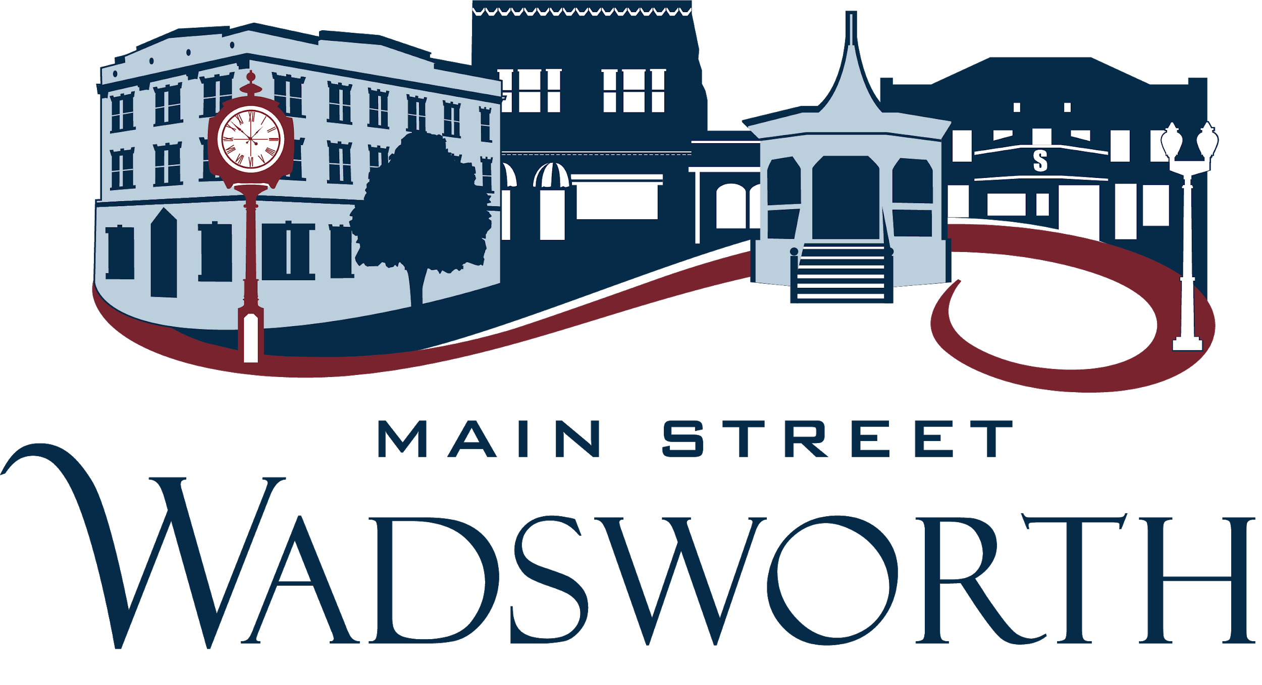

Main Street Wadsworth, a 501(c)3 organization dedicated to the historic preservation and economic revitalization of our downtown, is seeking up to three individuals to join its Board of Directors in 2019. Prospective board members must be passionate about Wadsworth and willing to get involved in the operation of the organization. This is a working board, and all members are required to sit on one of four Main Street Wadsworth committees:

Promotions - handles downtown events, social media and marketing

Organization - handles Board management, public relations, fundraising, and volunteer management

Economic Vitality - serves as a resource for existing downtown businesses, assists with new business development, and initiates market research

Design - works to beautify the downtown, educates business owners and building owners about good design, influences downtown development, and provides design advice

Board terms are 3 years. Board members are expected to attend monthly board meetings (currently held on the third Wednesday of the month at 7:30 am), and to volunteer at least 10 hours per month.

More information about the Main Street program can be found here <https://www.heritageohio.org/programs/ohio-main-street-program/>

Interested applicants should complete the attached application and submit it no later than **Friday, November 23, 2018**, via email to [treasurer@mainstreetwadsworth.org](mailto:treasurer@mainstreetwadsworth.org) or via regular mail to:

Main Street Wadsworth  
Attn: Board of Directors Search  
102 Main St. Suite 20  
Wadsworth, OH 44281

Thank you for your interest in Main Street Wadsworth and your community!

**Main Street Wadsworth  
Board of Directors Application**

**Name:**

**Address:**

**Daytime Phone:**

**Evening Phone:**

**E-Mail Address:**

**Profession/Occupation:**

***Please list current or prior board experience:***

**Organization Dates**

**Why are you interested in serving on the Board?**

**What skills and background do you offer as a board member**

***Please list any relevant skills/experience in the following areas:***

F**undraising**

**Tech/Web design/Social Media**

**Accounting/Bookkeeping**

**Nonprofit Management/Leadership/Legal**

**Commercial/Business Development**